**Lesson 6 Demo 10**

**Working with IPv4_IPv6 Dual-Stack**



Steps to be followed:

1. Creating a default dual-stack service
2. Creating a preferred dual-stack service

**Step 1: Creating a default dual-stack service**

* 1. Create a configuration file for the default dual-stack using the following command:

***vi default-dualstack.yaml***



* 1. Add the following code to the file created:

***apiVersion: v1***

***kind: Service***

***metadata:***

***name: my-service***

***labels:***

***app: MyApp***

***spec:***

***selector:***

***app: MyApp***

***ports:***

***- protocol: TCP***

***port: 80***

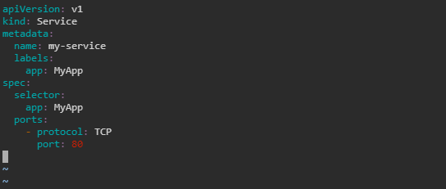

* 1. Create the resource by using the following command:

***kubectl apply -f default-dualstack.yaml***



* 1. Describe the service by using the following command:

***kubectl describe svc my-service***

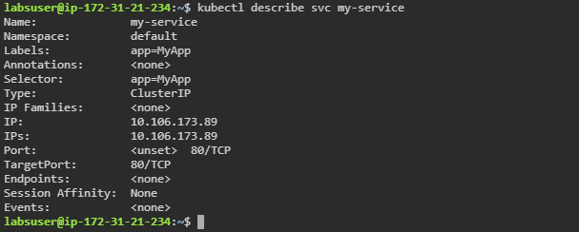

**Step 2: Creating a preferred dual-stack service**

1. Create a configuration file for the preferred dual-stack service by using the following command:

***vi preferred-dualstack.yaml***



1. Add the following code to the file created:

***apiVersion: v1***

***kind: Service***

***metadata:***

***name: my-service1***

***labels:***

***app: MyApp***

***spec:***

***ipFamilyPolicy: PreferDualStack***

***selector:***

***app: MyApp***

***ports:***

***- protocol: TCP***

***port: 80***

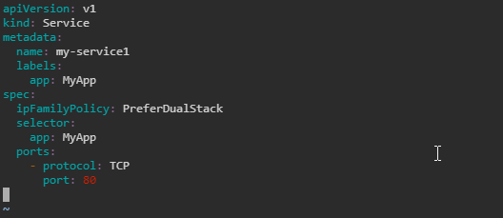

1. Create the resource using the following command:

***kubectl apply -f preferred-dualstack.yaml***



1. Check the created service with the following command:

***kubectl describe svc my-service1***

